

Mohammad Ali Jinnah University

Chartered by Government of Sindh - Recognized by HEC

**Assignment 2**

**Name:** Muhamad Fahad

**Id:** FA19-BSSE-0014

**Subject:** Software Engineering Lab (CS 3111)

**Section:** CM

**Teacher:** Sir Abdul basit

**Date:** Thursday, December 17, 2020

**Q1. Draw sequence diagram for given scenario (7 points).**

**Music Player:**

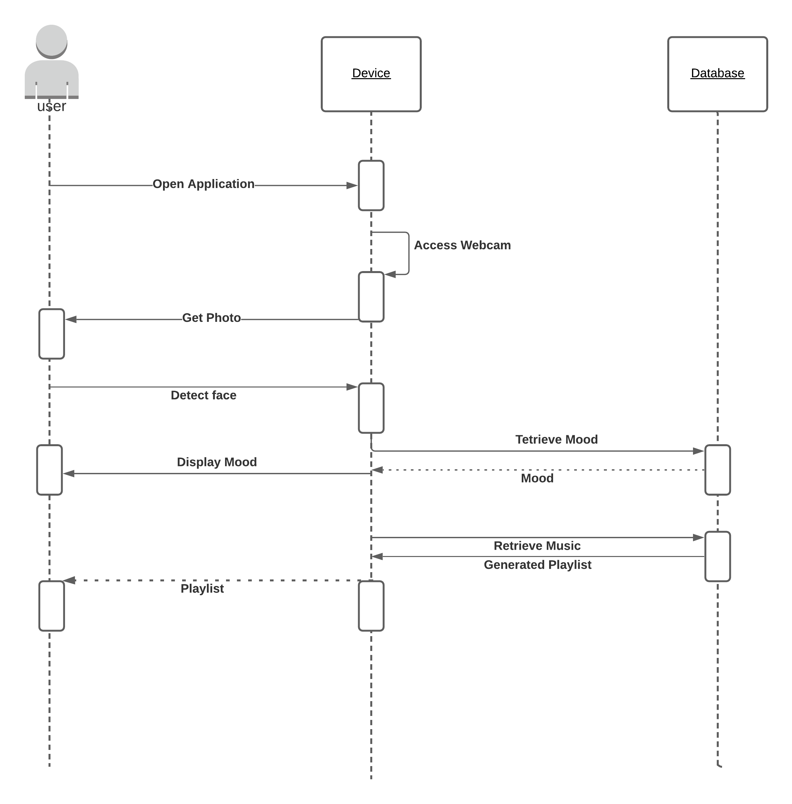

**Q2. Draw sequence diagram for given scenario (8 points)**

**ATM Transaction:**

